C Language Basics
Let’s start by typing our first code which is: -
#include <stdio.h>
This statement is a preprocessor directive we are telling compiler to include standard input and output library. It contains a lot useful functions for output and input, we need this header files in order to display text to the screen.
Next code is: -
Int which mean Integer
Int main() { }
Your program won’t run without this main function; The main function is the entry point of our program.
Example: -
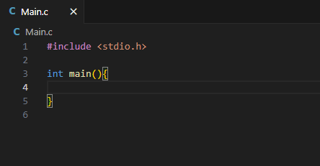

Next code is: -
Return 0;
In C programing Language the main function is expected to return an integer it returns it to the operating system, This integer which is 0 serves as an exit code. 0 indicates that the program ran successfully, a none 0 value typically indicates error.
In older versions of C like C89 (C Language 1989) and C90 (C Language 1990) omitting this statement will lead to undefined behavior. But in later standards like C99 (C Language 1999) or later you can omit this statement but it’s considered a good practice to include this Return 0; statement just for backwards compatibility.
Next code is: -
printf(“Hello World”);
Whatever we want to write we are going to write it with the double quotes “ ”.
When we want to run this program, we are going to click on the run button. Example: -
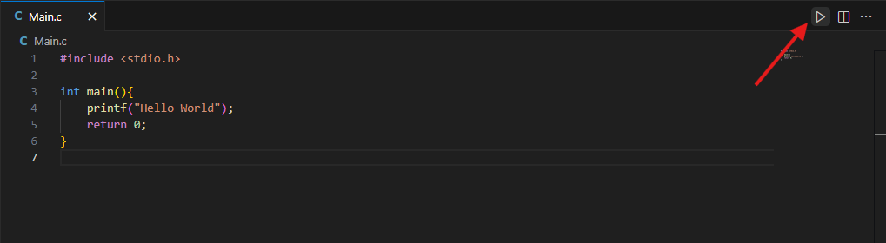

After clicking the run button as shown in the picture above, we are going to see a terminal pop up as shown in the picture below
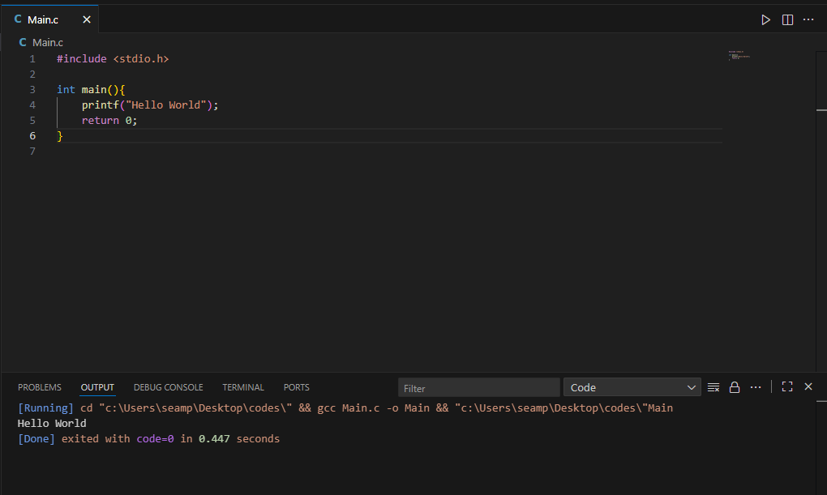
Let’s add another statement and make sure to add the semi-Colom ( ; )at the end
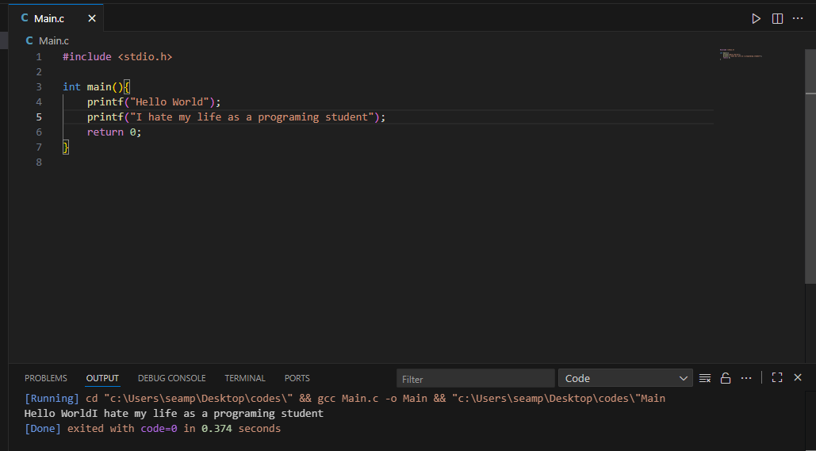
One issue we are running into is that we are displaying all of the text in one line, To move down to the next line you can add a new line character which is \n, Example; -
[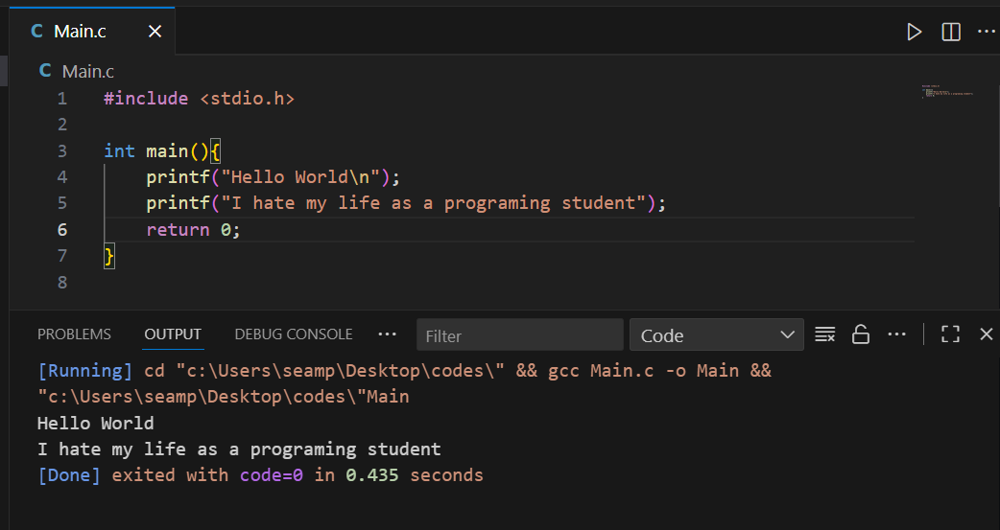
Now we can see that the text that once was a one line became a two different line like just hitting the Enter key button on our keyboard but in C language we use \n to separate lines.
Now we are going to discuss comments; to write a comment in C language we are going to use two forward slashes // then you can write some text for example: -
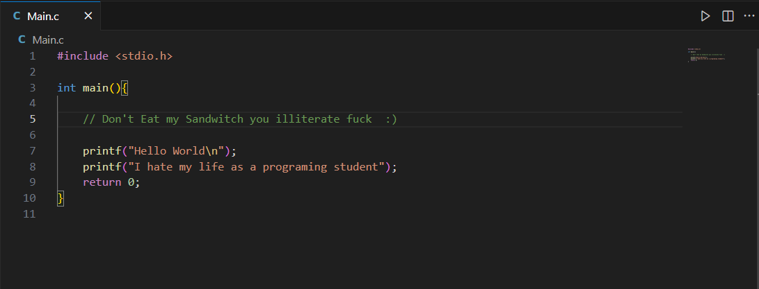
Comments won’t display as output and you can see that the text color is green but that is a feature of Vs Code, if we run this program, we don’t see this comment we still have our own output.
Comments are useful as notes for yourself or for the other developers, you can also write a multi-line comment.
To start a multi-line comment, use a forward slash and then an asterisk. Example: -
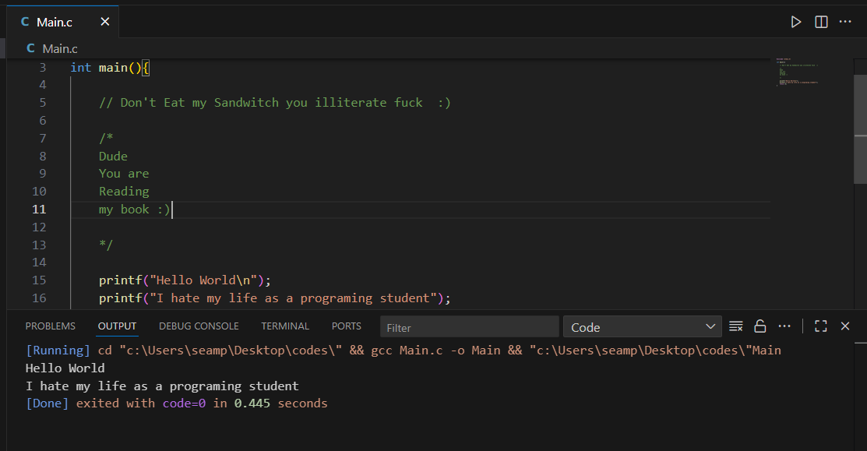
This also won’t display as an output either, we still got our text in the output terminal below nothing changed.
Variable in C Language
What is Variable?
Variable is a reusable container for a value. The variable behaves as if it were the value it contains.
Let’s begin with the data type int meaning Integer then we need a unique name for this variable, Let’s say we working with ages we are going to type this command.
Int age = 102;
we assigned this variable with a value using equals ( = ) let’s say you are 102 years old in C programming language we have to end each statement with semi colon ( ; ) So we can use this variable which is age and it will behave as if it was the number 102 to display this variable, we can use the printf statement by using this command: -
In C programming language to display a variable we have to use format specifier.
Let’s say we have a string of text which is “You are 102 years old” instead of typing It like this we will have to use a new command and its %d. D stands for decimal
printf(“You are %d years old, age”);
Look at the picture below to understand it more clearly: -
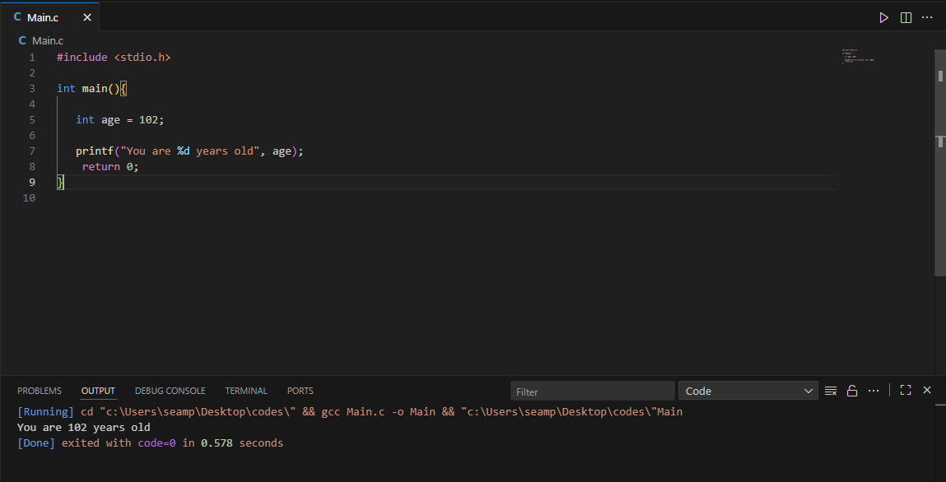
After running the code, it displayed You are 102 years old by naming a variable and adding a value to it so it can behave as it in our case the value was 102 and the variable was age.
So int is a whole number a whole integer, If we say 102.5 which is my half birthday we will end up truncating that decimal portion because integers can’t store decimals.
To store a whole number, we can use Integer lets create another variable.
Another example we could use is a year. Look at this Example: -
Note: % is a format specifier and d is for decimal
Int year = 2025;
Printf(“The year is %d”, year);
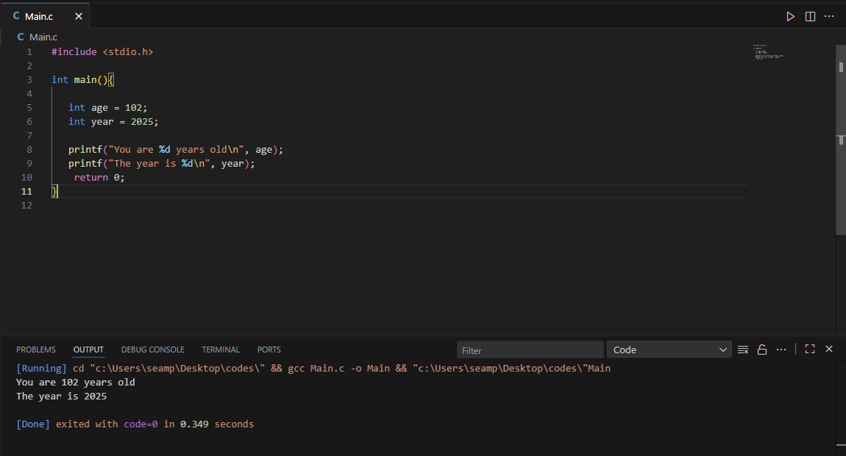
We can see clearly in the picture how it turned out and let’s not forget the spacing by using the code \n.
Another example of an Integer is quantity let’s say we are buying a product or some kind of fruits. You wouldn’t have a half product, right? Like half apple or half apple Samsung device quantity would be a whole number.
Int quantity = 5;
Printf(“You have ordered %d x Items\n”, quantity);
So those are Integers they are just whole numbers they don’t have capability of storing a decimal portion that’s where the next command is coming.
To store a decimal portion, you can use a float meaning a floating-point number.
A good example a number that contains a decimal perhaps a gpa (grade point average)
Float gpa = 3.5;
As we saw in a previous example, we used a format specifier %d but for a floating-point number we are going to use %f.
Printf(“Your gpa is %f\n”, gpa);
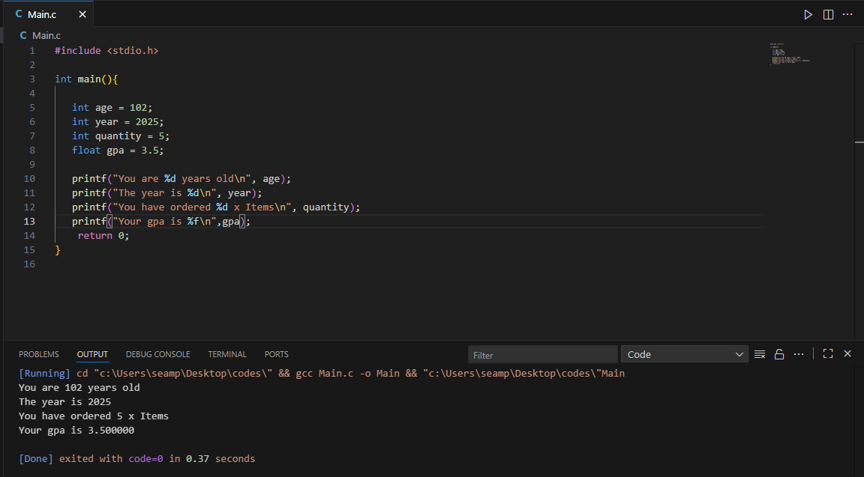
By default, behavior of displaying 6 digits after the decimal when working with floating point numbers, you could add %.1f to display a given amount of number you can place literally any number whether its 1 or 3 or 6. We will cover that in a future topic.
Another good example of a floating number is price
float price = 20.99;
printf(“The price is $%f\n”, price);
After running the code, it will show you 6 more digits like 20.990000 how to solve that is to add digits to the format specifier like 2 or 3 or maybe 1 example %.2f.
Look at the picture below to understand: -
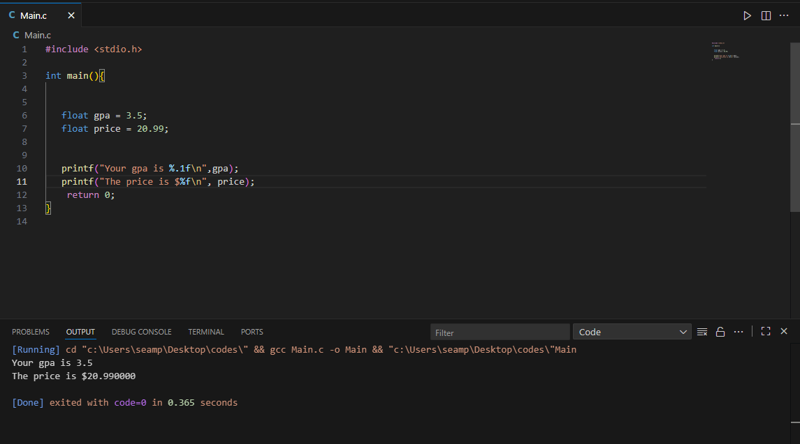
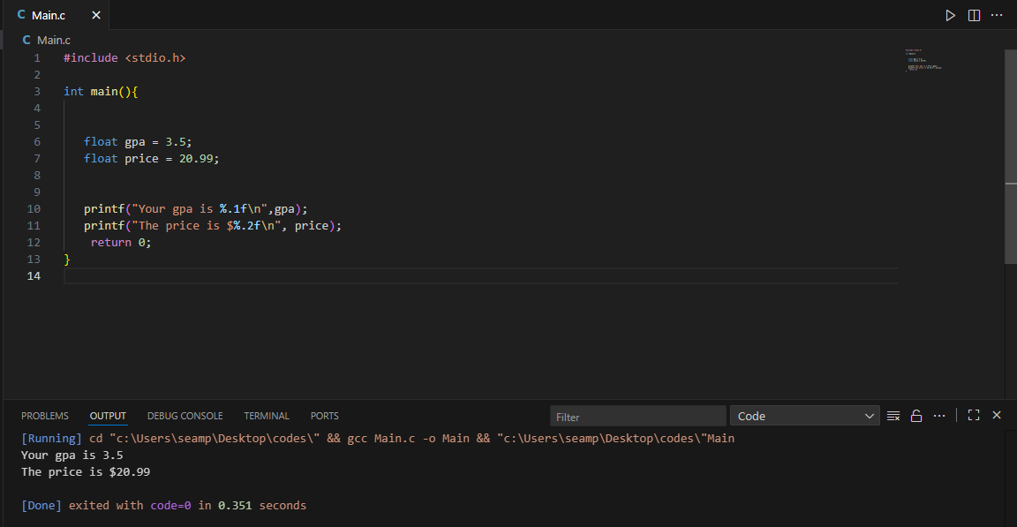
Another example of a floating-point number is Temperature example: -
float temperature = -12.6;
printf(“The temperature outside is %f\n”, temperature);
Now you may wonder what is the \n command after every statement? Simply it’s as we previously mentioned it’s for a new line character.
Look at the picture below to understand: -
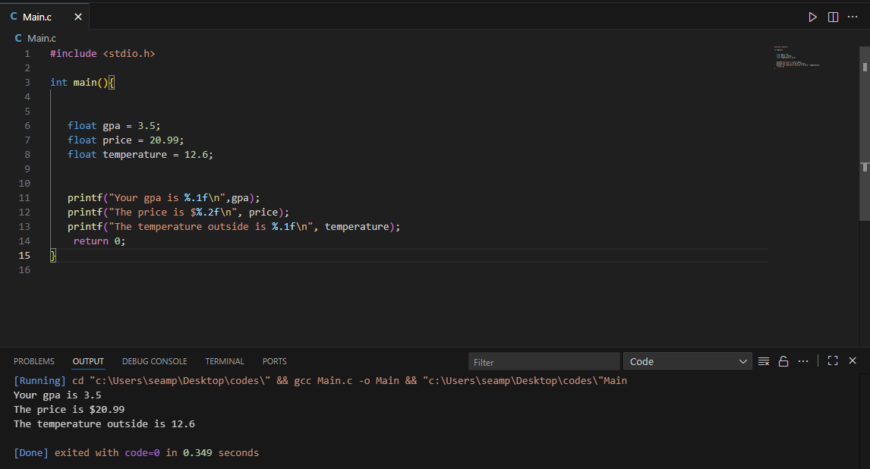
We only have the capability storing 6 to 7 digits after the decimal if you need more precision such as if you are working with PI, you can use a different type know as the double. Let me show you how it works.
double pi = 6.5294857683019273;
With doubles you can store up to 15 to 16 digits after the decimal and then to display a double simply type this command: -
Printf(“The value of pi is %lf\n”, pi);
Working with double we have to use %lf which stands for Long Floating point.
The default behavior of C is to display 6 digits after the decimal.
So, if we want to display 15 to 16 digits we have to type %.15lf by using this command you can manually display 15 to 16 digits instead of 15 you can choose maybe 13 digits or 16 or maybe 9 digits its up to you to decide.
Look at the picture below to understand: -

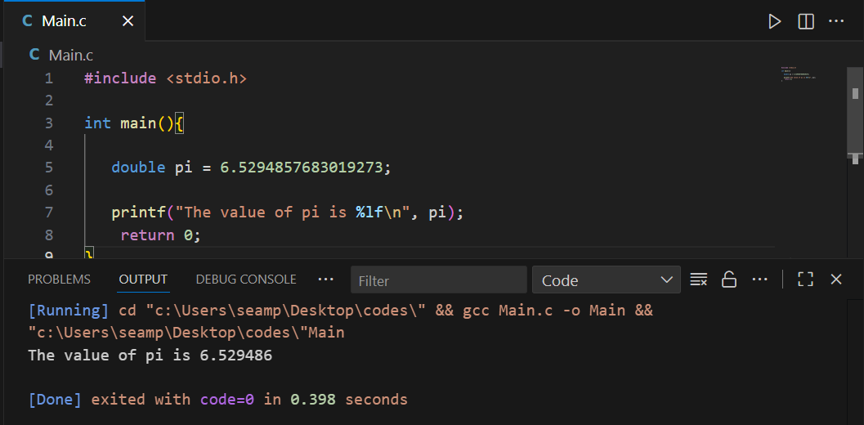
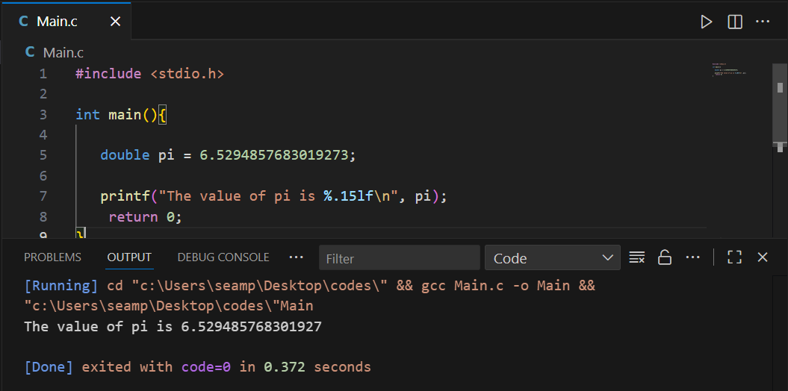
Another example could be E Euler’s number look at the example below: -
double e = 2.7182818284590;
printf("The value of e is %.15lf\n", e);
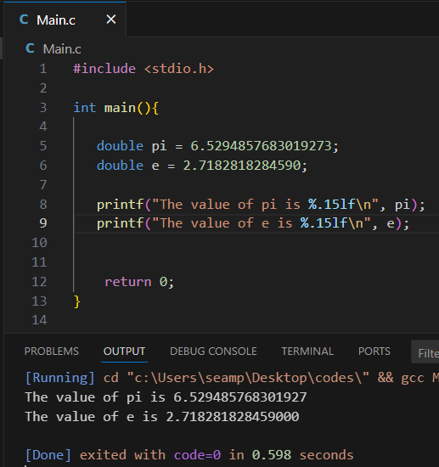
If you have a decimal number that need high precision you can use double.
With variables you can store more than just numbers characters another datatype is char meaning character.
Let’s say we have a letter grade we want to display a grade on an exam you got.
When working with characters we need to use a set single quotes ‘ ‘.
char grade = ‘A’;
printf(“Your grade is %c\n”, grade);

Another example is symbol.
char symbol = ‘!’;
printf(“Your favorite symbol is %c\n”, Symbol);
Look at the picture below to understand all the examples above mentioned.
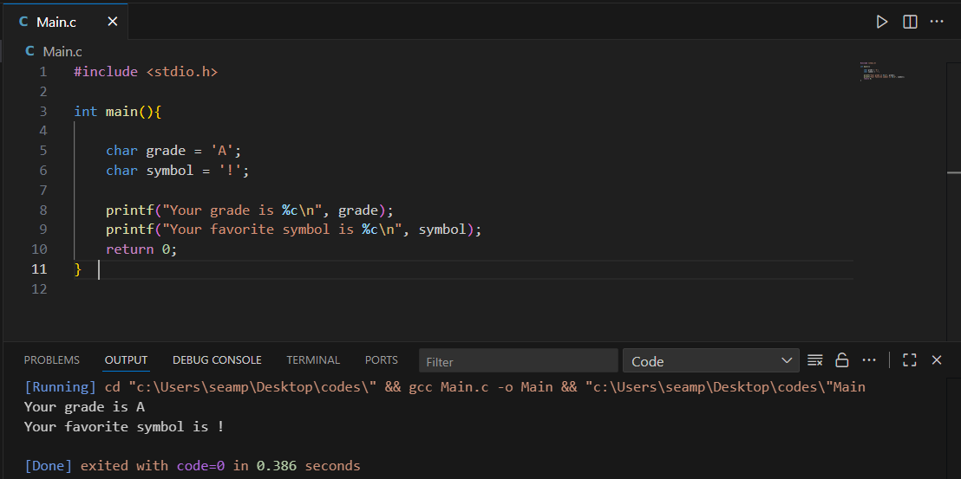
You can also use this command for currency like the U.S dollar sign example: -
Char currency = ‘$’;
Printf(“The currency is %c\n”, currency);
Those are chars they store a single character so to store more than character we use this command: -
Char name [ ] = “Charley Kurk”;
So this [ ] is called square brackets and its used and it can store more than values. Example: -
Printf(“Hello %s\n“, name);
The %s stands for ‘String’ is basically a sequence of characters think of it as a whole number or any text.
Look at the example below to understand how it works.

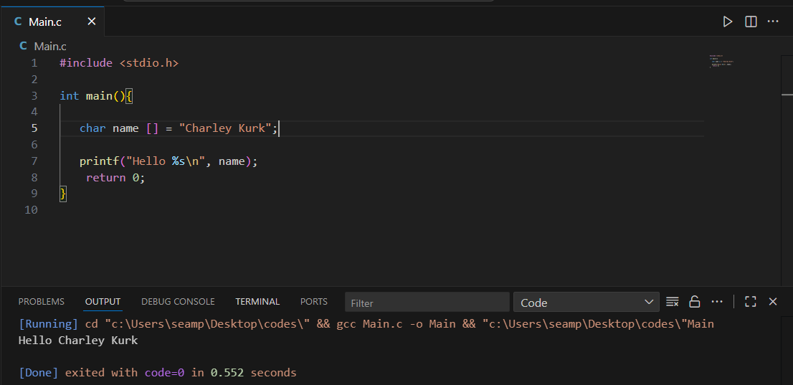
Another example is name of a food example: -
char Food [ ] = “Pizza and Burger”;
printf(“I love %s\n”, food);
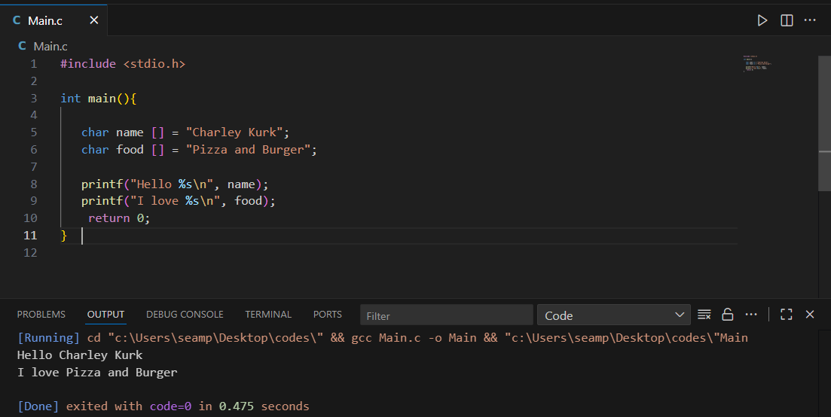
What is Bool?
Boolean is datatype that can have one of two values true or false 1 is true and 0 is false but to work with Booleans we have to include this header command
#include <stdbool.h> std stands for standard and it is standard Boolean.
Bool is also used to determine if a person is online or not
Bool isOnline = true;
Bool isOnline = false;
Pritnf(“%d”, isOnline);
We could use more accurate commands like if and else its for future lessons but here a quick rundown.
If (isOnline) {
Printf(“You are Online”);
}
Else {
Printf(“You are Online”);
}
Let’s give it a test run and see what’s going to happen.
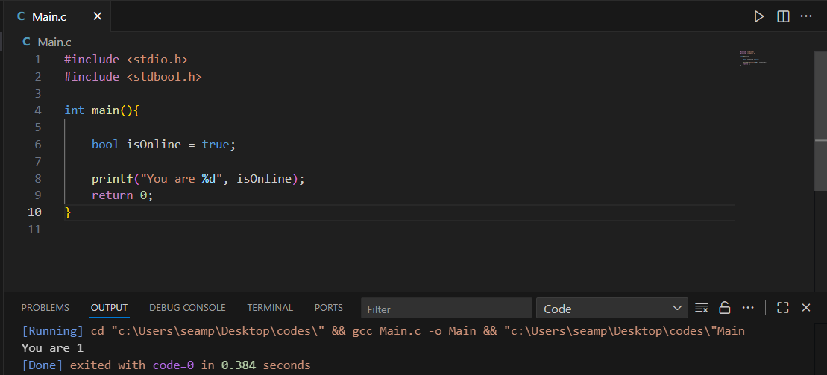

Another example if we changed true to false it will show 0
Look at the picture below
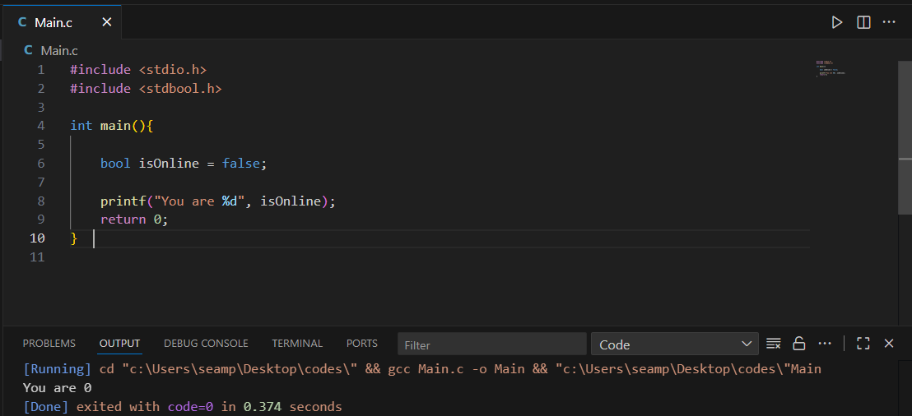
Now let’s see another example
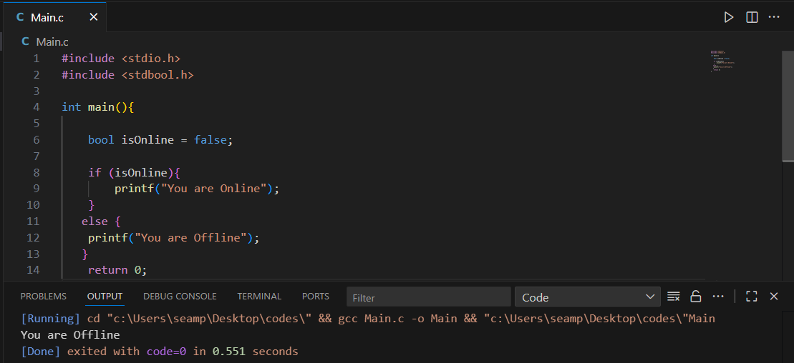
We can see its showing the phrase You are Offline if we turn it to true it will show the phrase you are Online.
Look at the picture below
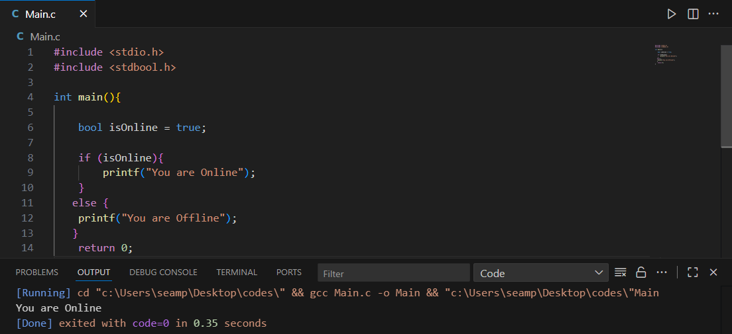
Look at this summery about the topic
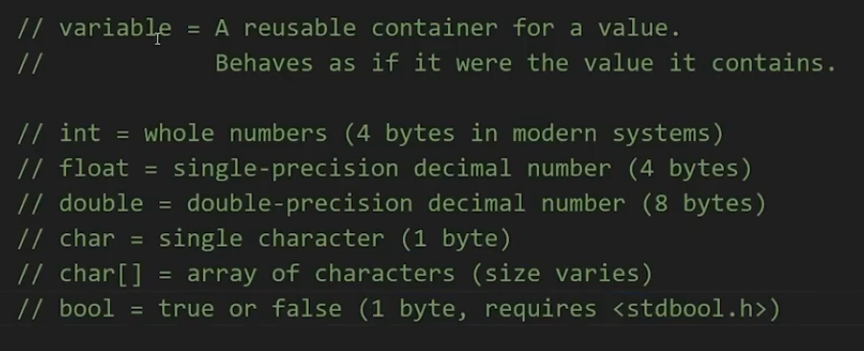

Format Specifier
What is format specifier?
Its special tokens that begin with % symbol, followed by a character that specifies the data type and optional modifiers (width, precision, flags). They control how data displayed or interpreted.
Between the percent sign (%) and corresponding letter of the data type there is special characters we can add to format the output.
Example: -
Here how to set the width when we display our output, we are going to have three numbers.
Int num1 = 1;
Int num2 = 10;
Int num3 = 100;

Printf(“%d\n”, num1);
Printf(“%d\n”, num2);
Printf(“%d\n”, num3);
So, between the percent (%) and the letter (D) we can put number, The number we place between these two characters will set the width for example lets put a number between them like number 3, The width specifies the minimum number of characters to print.
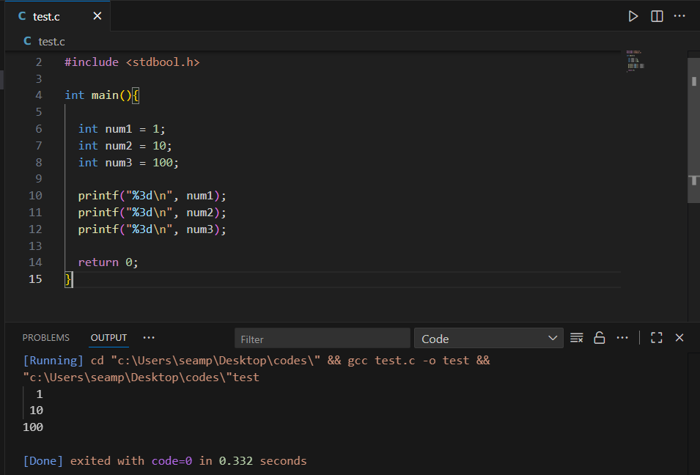
Now we are at least 3 characters including spaces, the number one has two spaces before it and the third character is number 1, and number 10 has only 1 space before it, and number 100 has zero spaces because number 100 already filling all the spaces.
Now we can left justify these values adding negative sign (-). Example: -
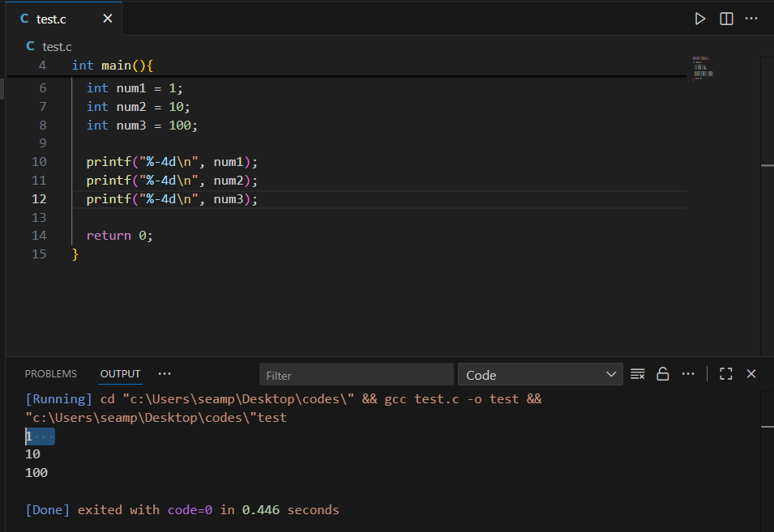
We can see that now the spaces on the left and number 1 has 4 spaces after it as shown in the picture above.
You can also add leading zero by putting 0 before the percentage sign example: -
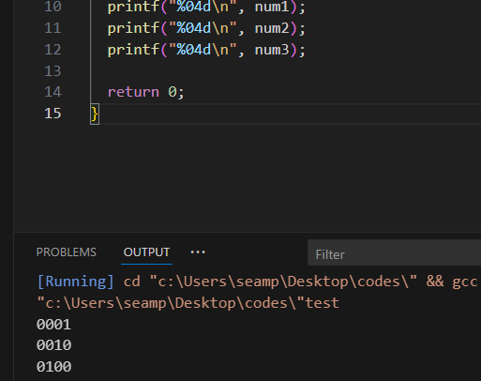
We can see that it has now zeros before it rather than having spaces like before each value will have zeros.
Now maybe num3 is negative -100, Before the letter that corresponds to the data type if you add a plus sign (+), If number is positive, you will have a plus sign if its negative you will have a negative sign this could be good for accounting. Example: -
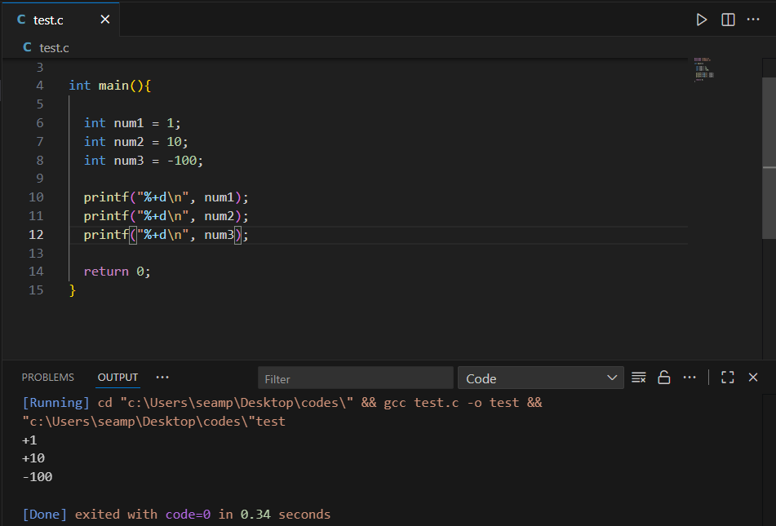
Now let’s move to precision. Examples: -
Float price1 = 19.99;
Float price2 = 1.50;
Float price3 = -100.00;
printf("%f\n", price1);
printf("%f\n", price2);
printf("%f\n", price3);
Look at the picture below to understand the following: -

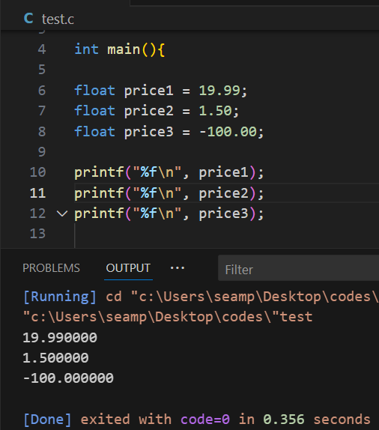
Here the floating-point number our prices the default behavior of C language is to display 6 digits after the decimal when displaying floating point number. Before the corresponding letter data type, you can add dot or period then the amount digits to display after the decimal. if we are working with prices 2 would be good to display two digits after the decimal for example dollars and cents 19.99$.
Look at the picture below to understand: -
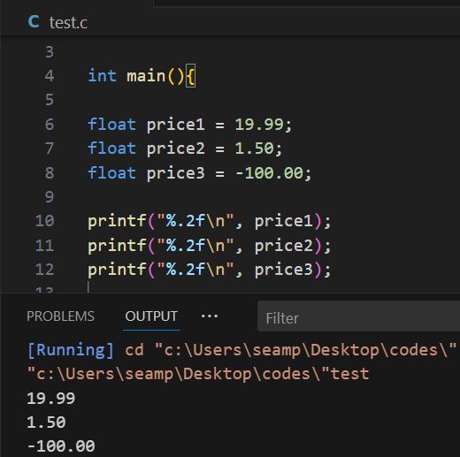
If this were point 1, we would display one digit after the decimal.
Keep in mind that the output will be rounded if we were to display it according to the rounding numbers rule in math, If the number is greater than 5 then we will round it up, if its less than 5 we will round it down. So, 19.99 becomes 20.0.
And with what we have learned you can combine width, precision and flags together.
For example: - 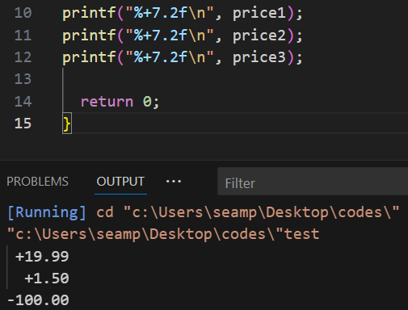
Arithmetic Operators
Arithmetic Operators = + - * / % ++ --
int x = 2;
int y = 3;
int z = 0;
So, Z is going to store our result after add or multiply the X and Y.
Example
For basic edition we are going to write
Z = X + Y;
Z = X – Y;
Z = X * Y;
Z= X / Y;
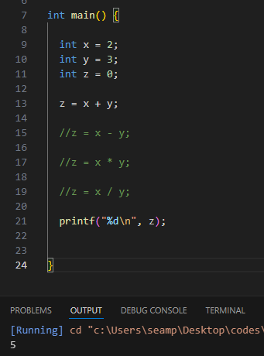

2 + 3 = 5 and we are storing that withing Z.
Division is going to be a little strange if we are working with Integers let’s see what happens.
Z= X / Y;
Printf(“%d\n”,z);
Normally 2 divided by 3 that should be 0.66666 repeating, when we run the code, we get 0 because we are working with Integers. Integers can’t store decimal portions, if Z was a floating-point number, you will also need to change the format specifier and an F and let’s see what happens after we run it.
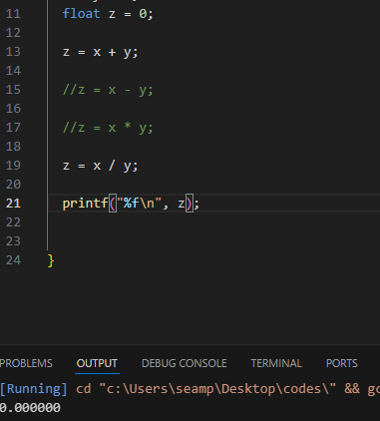
We got Zeros but its floating-point number, what we are doing is integer division if we are dividing by integer like X and Y, we can’t retain that decimal portions so we have to change X and Y to floating point numbers.
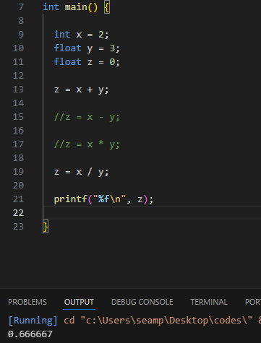
After running the code, we should get 0.666 etc.
Let’s move to modules operator that’s going to give you the remainder of any division.
int x = 10;
int y = 3;
int z = 0;
Z = X % Y;
The modules operator gives you the remainder of any division. Ten divided by three doesn’t divide evenly there is a remainder of one. Think it as a class of 10 students the teacher said get into groups of 3 and there is one student left who doesn’t fit the groups of three.
Now if Y were two well ten divides by two evenly think of it like this way the teacher said get into groups of 2 there is 10 students in the class that is 5 students by two groups that’s even.
The modules operator would be great if determining number is even a rod.
Let’s move to increment and decrement operator.
Increment is represented by two pluses ( ++ ) and decrement two minuses ( -- )
int x = 10;
X++;
printf("%d\n", x);
if we take X and add ++ we would increment it by one. Example X is 10 we add two pluses that would be 11 and if we decrement it that would be 9.
You see increment and decrement operators a lot when working on loops when we need some way to cou nt the cycles, how many times this loop has cycled.
There is also something called augment assignment operators. These would apply if you are reassigning the same variable. Now lets say that X is ten if I wanted to add a number to X and reassign it for example 2 we can type: -
X = X + 2; and that should give you 12 but there is a shortcut and its : -
X+=2; And that would do the same thing gives you the number 12. We can do the same with subtracting, Multiplying and dividing.
X = X – 2; OR X-=2;
X = X / 2; OR X/=2;
X = X * 2; OR X*=2;
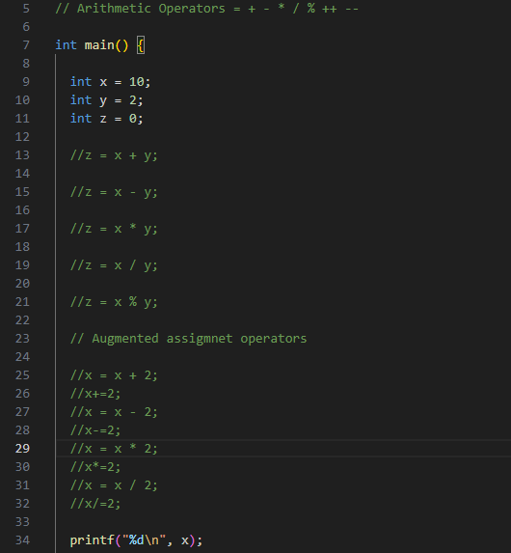

Chapter 2
Let’s start by assigning some Variables.
Int age;
Float gpa;
Char grade;
Char name[30];
Rather than assigning something to the integers right away for example int age = 25;
Just temporarily we are going to declare this variable but not yet assign it.
Since we are not giving the integer Char name[ ]; a value such as typing your personal name, we have to specify a size if we are not assigning it. So, let’s say 30 meaning thirty bits or think of it as 30 characters, our name has maximum size of thirty characters. Feel free to set this to a different number if you like.
After running these integers without assigning them we are going to get undefined result for example: -
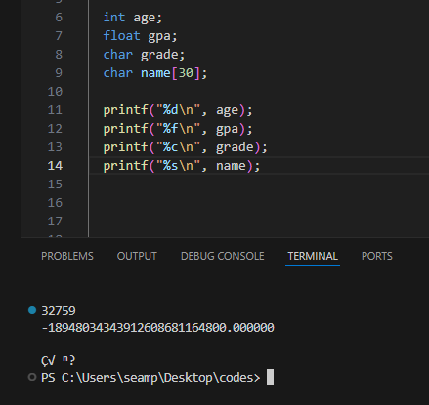
After getting this undefined result let’s assign the integers with value.

Int age = 0;
Float gpa = 0.0f; F if it’s a float, F isn’t needed for a double.
Char grade = ‘\0’; \0 = Null terminator
Char name[30] = “ ”; For this we are going to leave it empty but still its going to take 30 characters.
So how do we put stuff within them?
We are going to use a new code called Scanf Here how it works
Rather than using printf we are going to use scanf to get user input or to let the user type something. Example: -
Scanf(“%d”, &age); “ & is the address operator basically we are saying at the address of our variable age we are going to stick a value here” let’s do a test run to understand more.
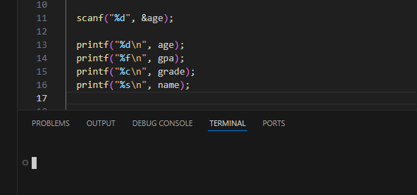
After running the code, we see blank in the terminal command that means we need to put a value here like age.
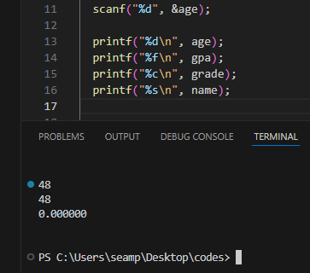
After running the code and entering a value like the age 48 we got some result as shown in the picture above.
Proceeding our scanf we need to let the user know that he has to type something so we are going to use printf.
Pritnf(“Enter your age:” ); Note: This has to be above the Scanf integer.
scanf("%d", &age);

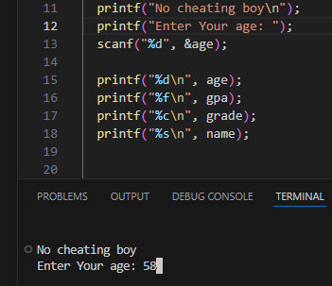
As we can see in the terminal, we are able to enter our age and then display it.
Let’s do another one but this time with floating point.
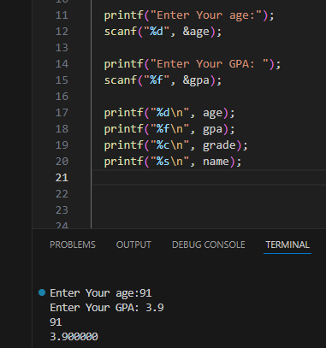
Let’s move the character integer
printf("Enter Your Grade:");
scanf(" %c", &grade);
There is a problem when trying to run the code when using the character integer because the machine won’t give you opportunity to type the letter grade after the gpa because the program spits its own output which is your entered age instead of the grade, we need to clear that problem before assigning our grade variable.
How we are going to do that is to put space before of the %c sign. Example: - scanf(" %c", &grade);
As you can see there is a space between the “ and %c and that tells our C program to skip over that new line character, and that’s a little shortcut to fic the problem.
Now let’s test and see it
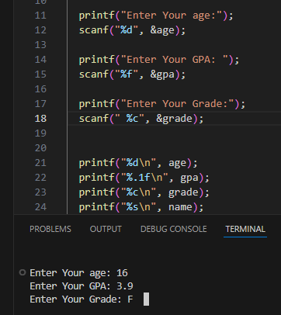

Now let’s assign a name there is a better option than the scanf but we are going to see first the scanf then we are going to try the better and easy option.
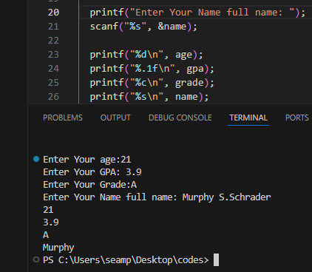
After typing our age, gpa, grade and our full name it only shows the first name and that’s because the scanf can’t read any white spaces this is because the scanf will stop reading after encountering any spaces if we type our full name we end up storing only our first name a solution to this is to use a different function named fgets which means: file get string.
And with fgets we have to change a few things around
printf("Enter Your Name full name: ");
fgets(name, 30, stdin); stdin stands for standard input
now if we were to change the size of name which is char name[30] = ""; let’s say we change it to 60 we have to change it too manually in the fgets function but there is a little trick to use is to calculate it how we are going to do that is by typing the sizeof( ); function and then passing our variable of name. So, if the size is 60, we can calculate it then we don’t have to type it manually every time.
After running the code, we encounter the same problem that we had with %c and fgets don’t have the luxury to skip it by just adding space before it. But there is a new function that can do that for us and it’s called getchar( ); that can also clear the new line character within the input buffer.
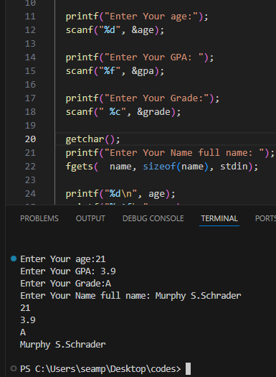
There is a new function that is going to help us in the future and it’s a header file and a function.
#include <string.h> This header file is for strings and it provides a lot of useful functions related to working with strings.
Following the fgets function we are going to take our name variable for example
Name[strlen( name) -1] = ‘\0’; Meaning string length
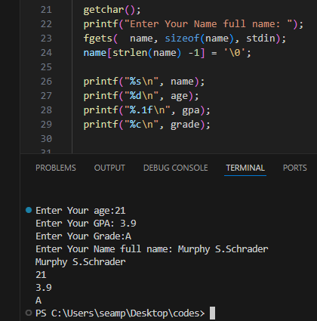
Shopping Cart
When creating a project, a good step is to declare all the variables you will need.
We need to hold the name of an item this can be string.
char item [50] = “”; Put the maximum number of the characters for an item this could be 10, 20 or even 50 characters.
Second, we will need a price this can be floating point number.
float price = 0.0f; if its double you can remove the F but this tells you and other developers that this should be a floating-point number.
Then a quantity how many items we are buying and this can be integer or int.
int quantity = 0;
We also need a currency and it can be character or a char.
char currency = ‘ $ ‘; pick any currency of your own if you like
And then we need a total this can be floating point number.
float total = 0.0f;
Now that we have our variables listed, now we will need prompts.
We are going to ask a user what they are buying.
printf("What item would you like to buy?: ");
fgets(item, sizeof(item), stdin);

printf("What is the price for each?: ");
scanf("%f", &price);

printf("How many would you like?: ");
scanf("%d", &quantity);
total = price * quantity;
printf("%f", total);
After typing the of the command, we run the code and interact with it.
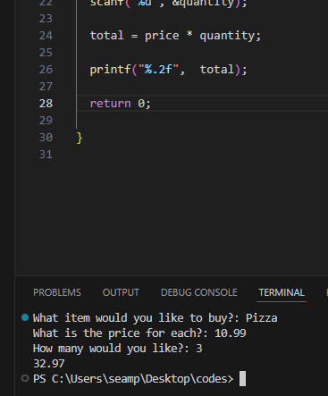
After running the code, we could see that there is no currency the way we need to do it in order for it to be seen with the total number that is 32.97 is the following command.
printf("%c%.2f", currency, total); We are going to add the character specifier next to the floating-point specifier as show above.
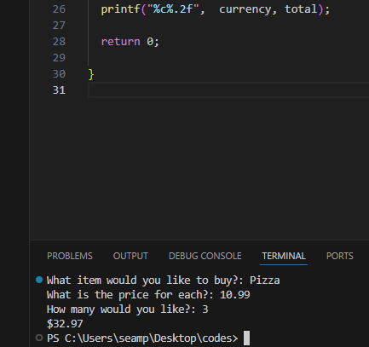
When printing variables you can list multiple format specifiers all on the same line if you need to.
Let’s print another statement.
printf("\nYou have bought %d %s\n", quantity, item);
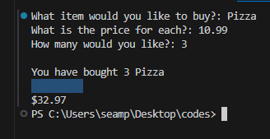
After running the code, we can see that there are a new line and the way to get rid of it is: -
First we need the help of a header which is
#include <string.h>
Second, we will use this command
item[strlen(item) - 1] = '\0'; Note: You should change the word item if it is something else like a job or a cat.
Let’s combine them and we got this result: -
printf("What item would you like to buy?: ");
fgets(item, sizeof(item), stdin);
item[strlen(item) - 1] = '\0';
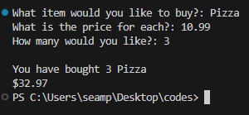
After running the code, we can see that the line is now gone.

Game Project
In this project we are going to learn how to make interactive game project.
First let’s write down our variables, we are going to work with strings so let’s add the string header first.
#include <string.h>
Now after adding the string header let’s write down our variables, there will be English naming but feel free to use your naming.
char noun[50] = “”;
char verb[50] = “”;
char adjective1[50] = “”;
char adjective2[50] = “”;
char adjective3[50] = “”;
After writing down the variables we need some prompts.
printf(“Enter an adjective (Description): ”);
printf(“Enter a noun ( animal or person): “);
printf(“Enter an adjective (Description): ”);
printf(“Enter a verb (Ending with -ing: ”);
printf(“Enter an adjective (Description): ”);
Now after writing down everything, we need, now we need to accept user input Since we are accepting strings including white spaces we will use fgets.
printf("Enter an adjective (Description): ");
fgets(adjective1, sizeof(adjective1), stdin);

printf("Enter a noun (animal or person): ");
fgets(noun, sizeof(noun), stdin);

printf("Enter an adjective (Description): ");
fgets(adjective2, sizeof(adjective2), stdin);

printf("Enter a verb (Ending with -ing): ");
fgets(verb, sizeof(verb), stdin);

printf("Enter an adjective (Description): ");
fgets(adjective3, sizeof(adjective3), stdin);
Temporarily let’s display our variables using printf.
printf(“%s\n”, noun);
printf(“%s\n”, verb);
printf(“%s\n”, adjective1);
printf(“%s\n”, adjective2);
printf(“%s\n”, adjective3);
After typing all these commands let’s do a test run and see what we are going to get.
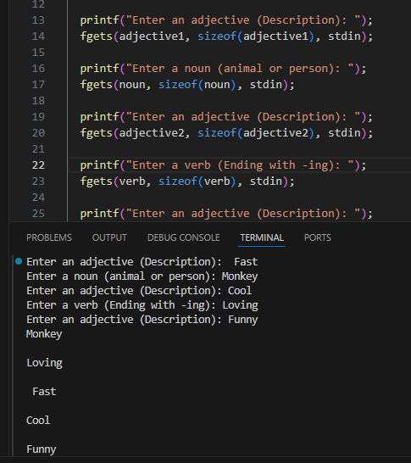
After running the code and typing something we got a little problem which is the newline character.
To fix that we will use strlen( ) function.
Look at the picture below to understand and write strlen( ) function as shown in the picture.
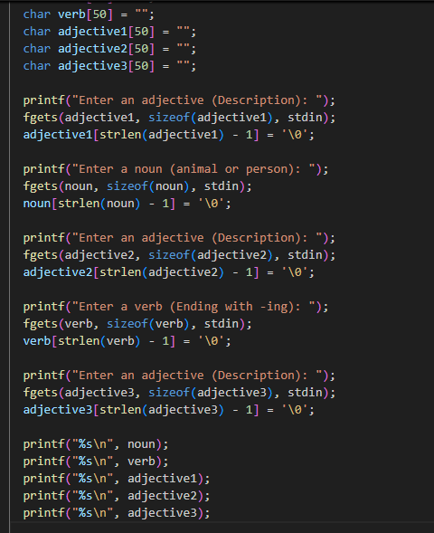
After writing down the strlen( ) function as shown in the picture do a running test to see if the problem is fixed.

After running the code, the newline character is gone in our code.
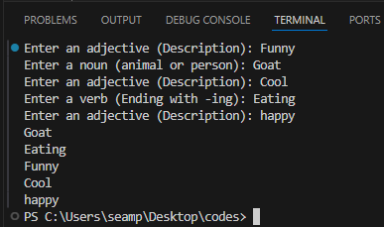
Let’s work on our story now we can get rid of the bottom statements that is: -
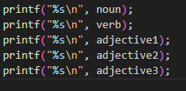
Feel free to write down your own story it will make you understand quickly.
printf("\nToday i went to the %s Zoo.\n", adjective1);
printf("In an exhibit, I saw a %s.\n", noun);
printf("%s was %s and %s! \n", noun, adjective2, verb);
printf("I was %s!\n", adjective3);
Look at the picture below to see the story.
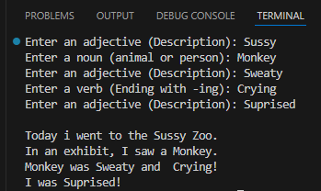
Useful Math Functions in C language
To work with these math functions, we need to include the following header file: -
#include <math.h>
Now let’s say we have a variable an integer of X equals to 9 and then in the end we will display it for example.
Int x = 9;
printf(“%d”, x);
The square root of 9 is 3, so we are going to type the following code and say: we will reassign x use the square root function which is sqrt(); and then pass a number or a variable for example I’m going to use x, the square root function will return the square root of whatever x is.
X is 9 and the square root of 9 is 3.
x = sqrt();
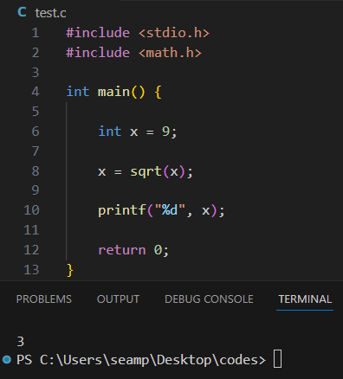
If we don’t add the header file #include <math.h> we will get an error message in the output window.
There is power function to raise a base to a given power let’s change a few things and test it.
int x = 2;
x = pow(x, 2);
printf(“%d”, x);
X is the base
2 is the raised to a given power. two to the power of two is 4.
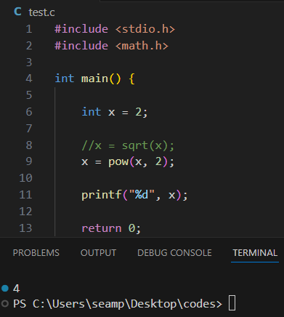
Let’s raise x to the power of 3 which would be 8, X to the power of 4 would be 16 and so on.
And that is pow(); meaning power, we can raise a base to given power.
Then we can round number let’s change x to be a floating-point number, x will equal 3.14 and let’s change our format specifier to %f for floating point number.
float x = 3.14;
x = round(x);
printf(“%f”, x);
Output will be: 3.000000

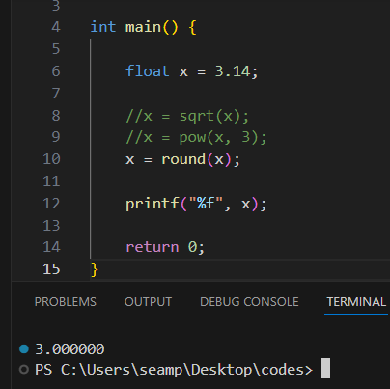
You can always round up by using the ceiling function.
float x = 3.14;
x = ceil(x);
printf(“%f”, x);
Output will be: 4.000000
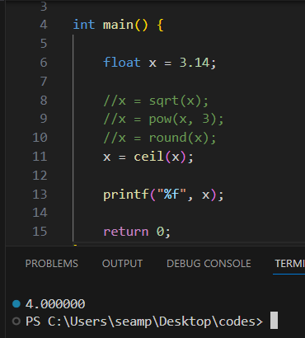
You can always round down by using the function floor, we will change 3,14 to 3.99 so we can round down the number.
float x = 3.99;
x = floor(x);
printf(“%f”, x);
Output will be: 3.000000
There is an absolute value function and we will use it for -3.
This syntax will change negative three to positive three. For example: -
Syntax : x = abs();
Int x = -3;
X = abs(x);
printf(“%d”, x);
Output will be: 3
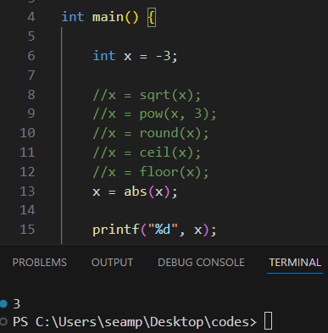
The absolute value of -3 is 3.
If you need the natural logarithm of a value variable the is Log function for it.
Syntax: log();
float x = 3;
x = log(x);
printf(“%f”, x);
This code is simply saying “what is natural logarithm of x?”
Output will be: 1.098612.
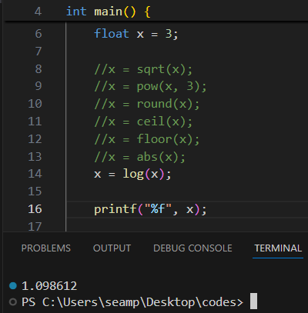
If you ever need to work with trigonometry there is a few trigonometry related functions, for example we can find to the sin value or variable by passing in a number of radians.
Syntax: sin();
float x = 45;
x = sin(x);
printf(“%f”, x);
X will be in radians; by using the sin function we will be given sin.
Output will be: 0.850904.
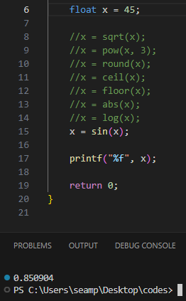
This will be useful if you ever wanted to use trigonometry.
Next will be Cos and it’s also used in trigonometry. For example:-
float x = 45;
x = cos(x);
printf(“%f”, x);
Output will be: 0.525322.
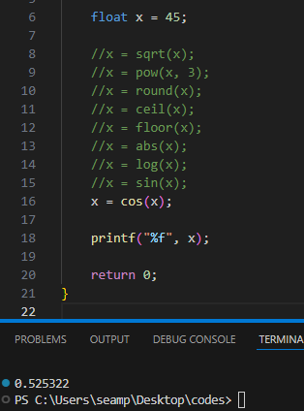
And then Tan for tangent.
float x = 45;
x = tan(x);
printf(“%f”, x);
Output will be: 1.619775.
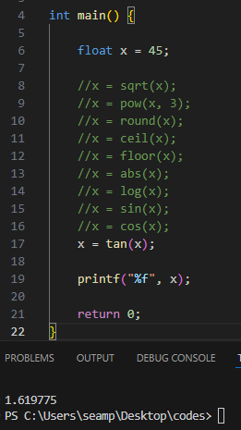
Important Syntaxes that we have learned today: -
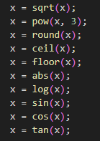

Next lesson 1:30:38

